Supplemental Information for:
Genomic and phenotypic divergence informs translocation strategies for an endangered freshwater fish
Liam U. Taylor, Edgar Benavides, Jeffrey W. Simmons, and Thomas J. Near

Table of Contents:
Supplemental Figure S1: fineRADstructure parameter traces Page 2
Supplemental Figure S2: SNAPP parameter traces Page 3
Supplemental Figure S3: Demographic model visual summaries Page 4
Supplemental Figure S4: Population structure model choice criteria Page 5
Supplemental Figure S5: Admixture proportions from fastStructure Page 6
Supplemental Figure S6: Coancestry matrix from fineRADstructure Page 7
Supplemental Figure S7: Population structure missing data comparisons Page 8
Supplemental Figure S8: Maximum-likelihood phylogeny with outgroups Page 9
Supplemental Figure S9: Demographic parameter distributions (migration both) Page 10
Supplemental Figure S10: Demographic parameter distributions (migration east->west) Page 11
Supplemental Table S1: F_{ST} missing data comparisons Page 12
Supplemental Table S2: Frequency tables for meristic and squamation traits Pages 13-17

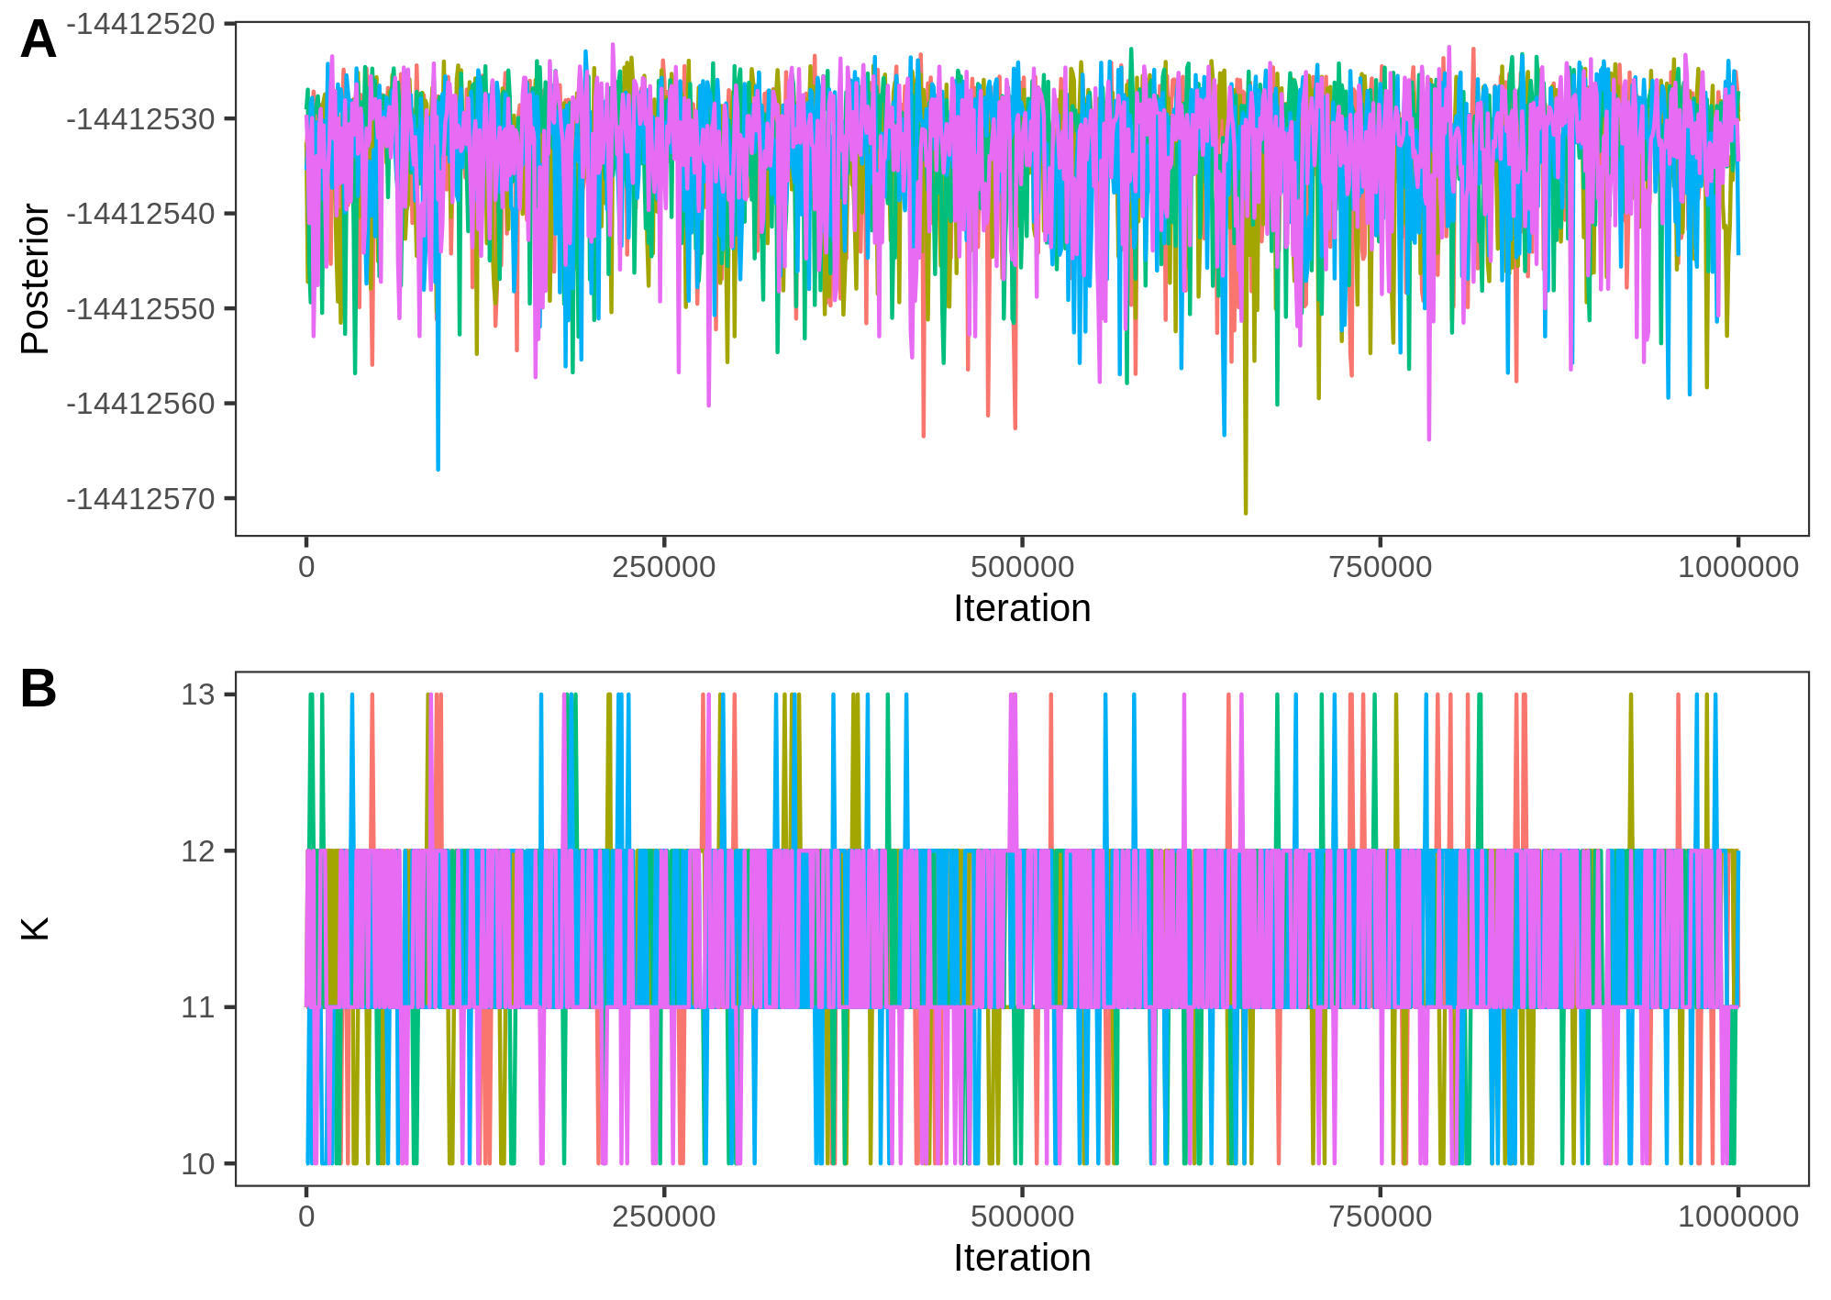
Supplemental Figure S1. Traces for fineRADstructure, after burn-in and thinning. Colors indicate each of five individual runs.

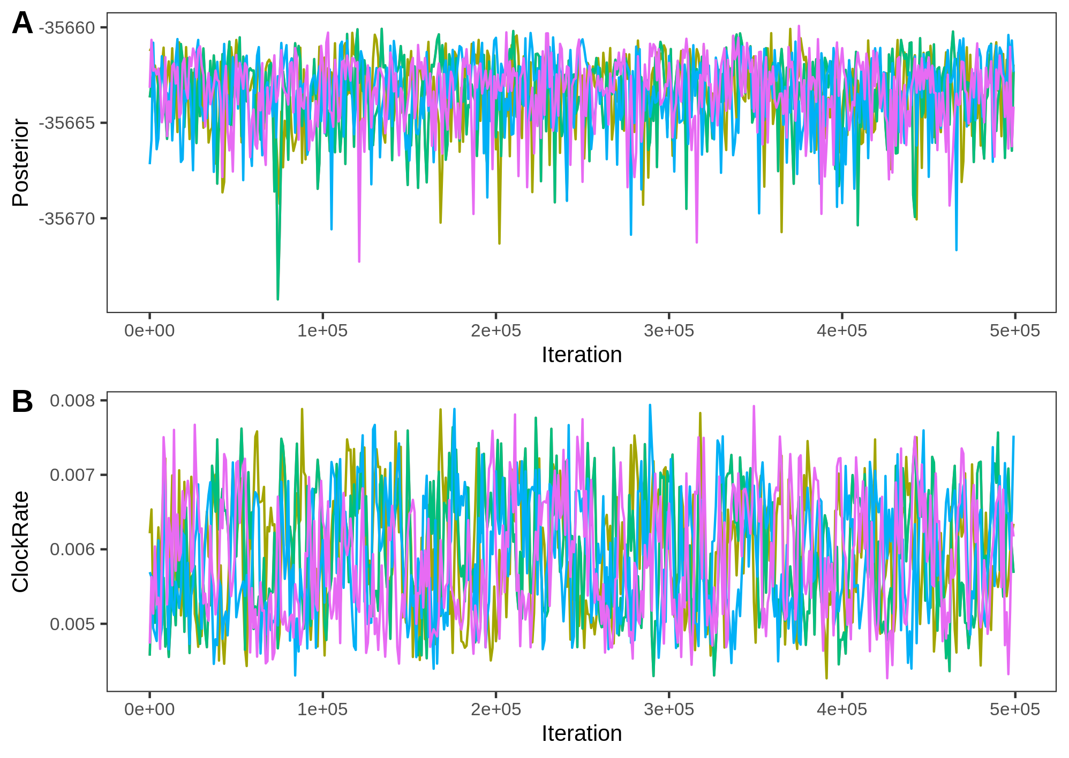
Supplemental Figure S2. Traces for SNAPP, after burn-in and thinning. Colors indicate each of five individual runs.

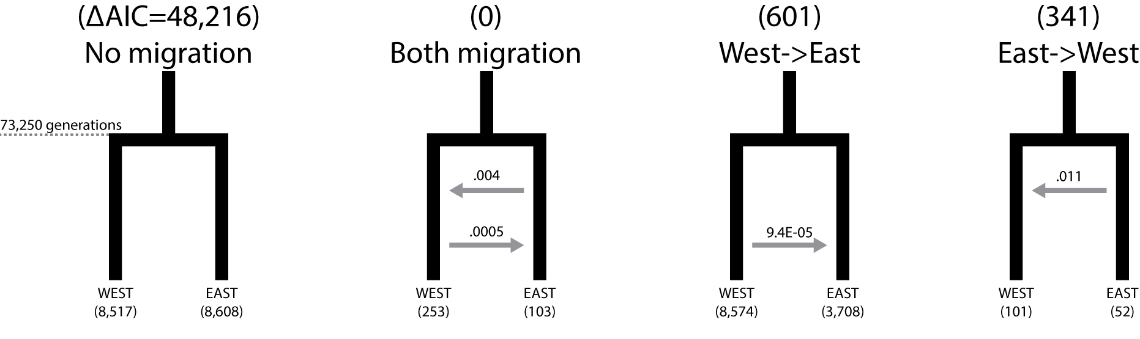 Supplemental Figure S3. Visual summaries of the four demographic models tested for Etheostoma akatulo populations. All models assumed no population growth and the same, fixed east-west divergence time estimated via SNAPP analysis. Parameter labels indicate the maximum likelihood parameter estimates from 1,000 initial replicates. Population size parameters are given as the number of diploid individuals. Continuous migration parameters are given as per-capita immigration rates. Above each model title is the ΔAIC value calculated from the best of 1,000 likelihood estimates calculated given the initial maximum likelihood parameter estimates. See the main text for bootstrapped parameter values from the AIC-selected models.
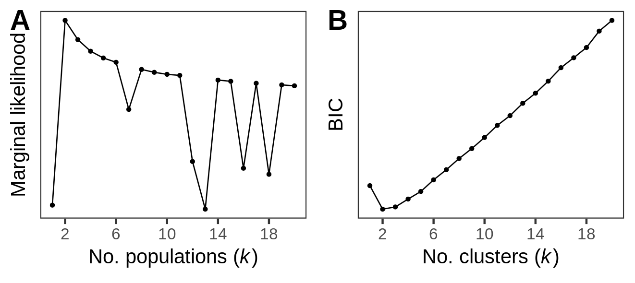
Supplemental Figure S4. Model choice criteria from fastStructure and DAPC favored k = 2 populations for Etheostoma akatulo. A: Approximate marginal likelihood of SNP variation is maximized by k = 2 populations in fastStructure. The ChooseK script provided with fastStructure also indicated that k = 2 was the number of model components used to best explain structure in the genetic data. B: Bayesian Information Criterion (BIC) was minimized at k = 2 genetic clusters in DAPC.

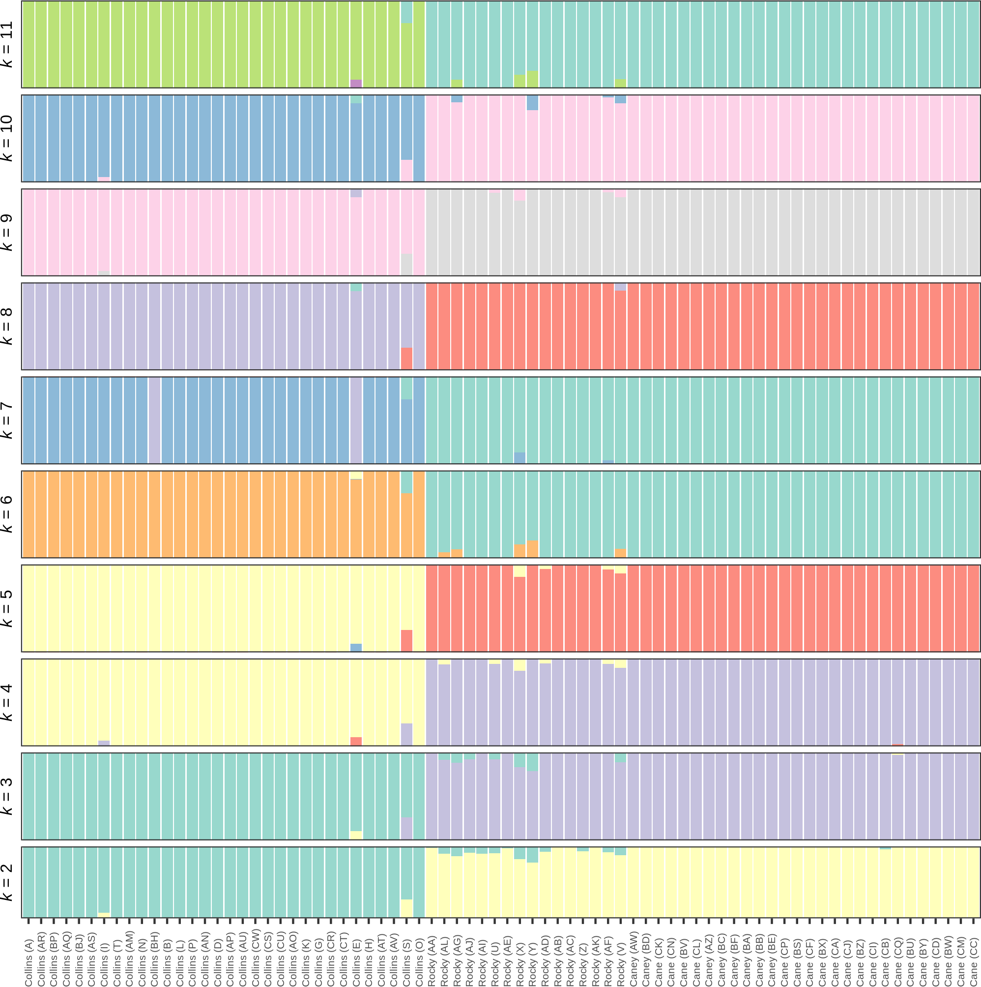
Supplemental Figure S5. Mean posterior mean admixture proportions from fastStructure at k values 2 through 11. Note proportions are often near zero for additional populations past k = 2.
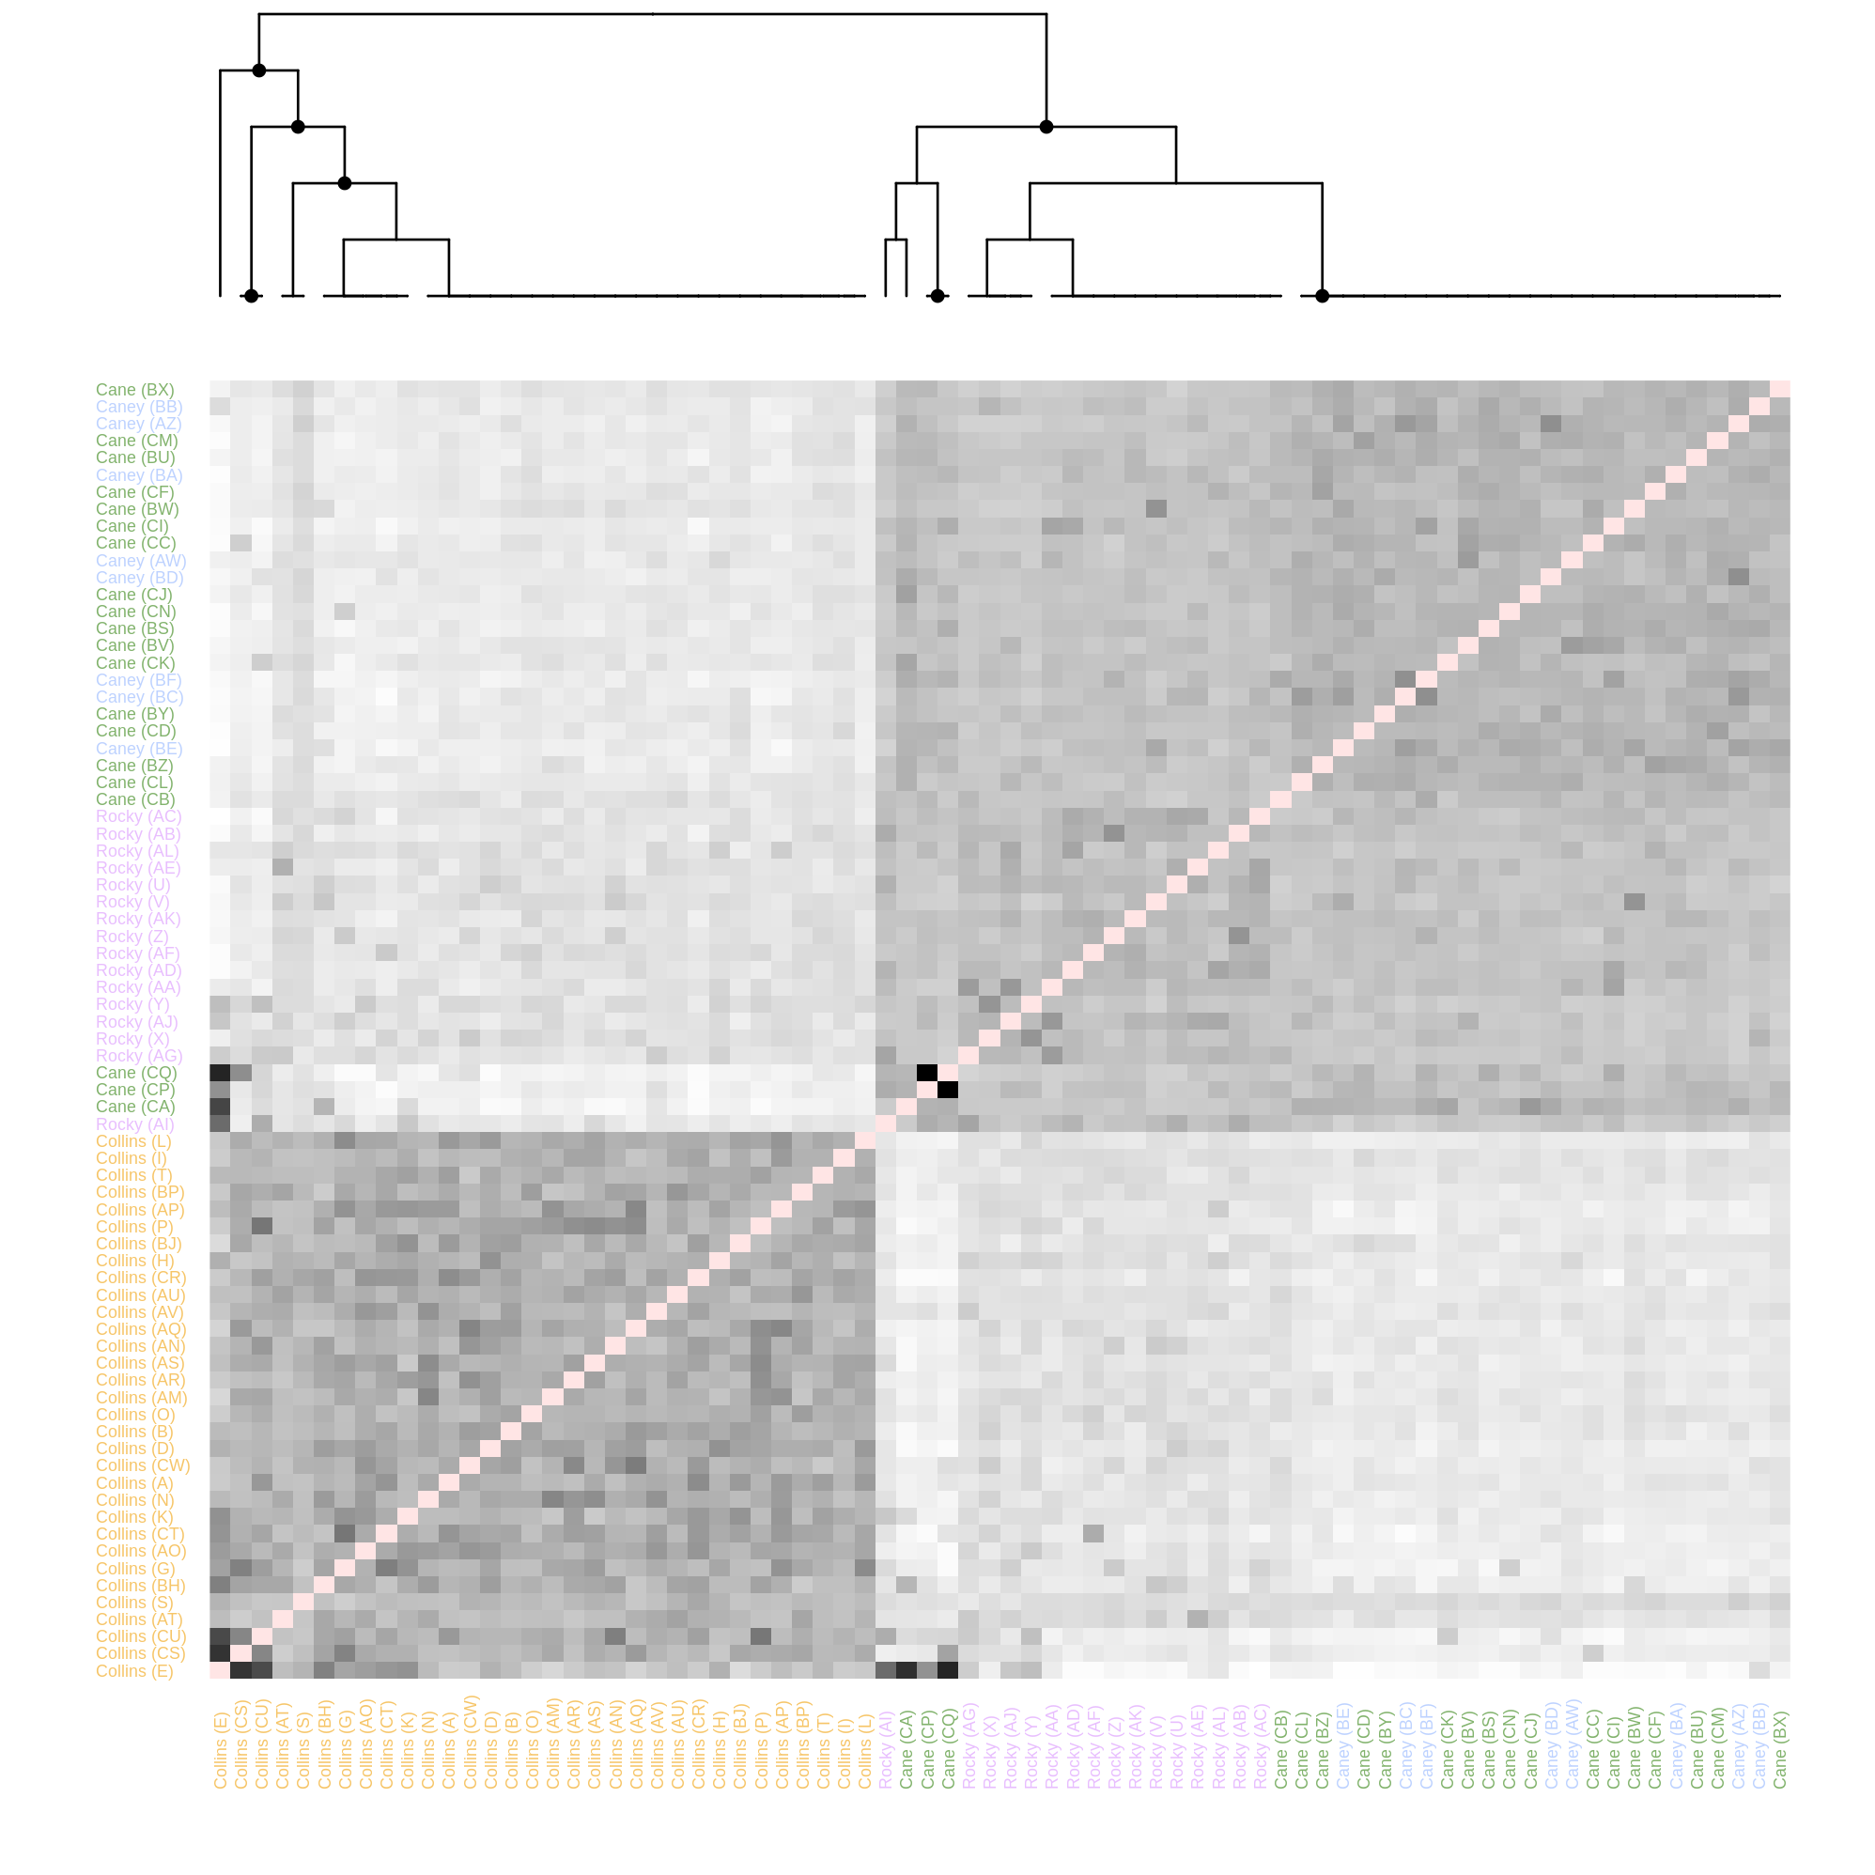
Supplemental Figure S6. Genetic coancestry analysis with fineRADstructure shows Etheostoma akatulo subpopulation structure nested within broader west (Collins River) and east (Rocky River, Cane Creek, and upper Caney Fork) groups. Darker cells designate higher coancestry for a pair of specimens. Tree tips indicate coancestry groups within which specimens share higher coancestry with the in-group than the out-group. Black nodes a posterior assignment probability ≥ 0.95 over 1,000 sampled tree iterations.
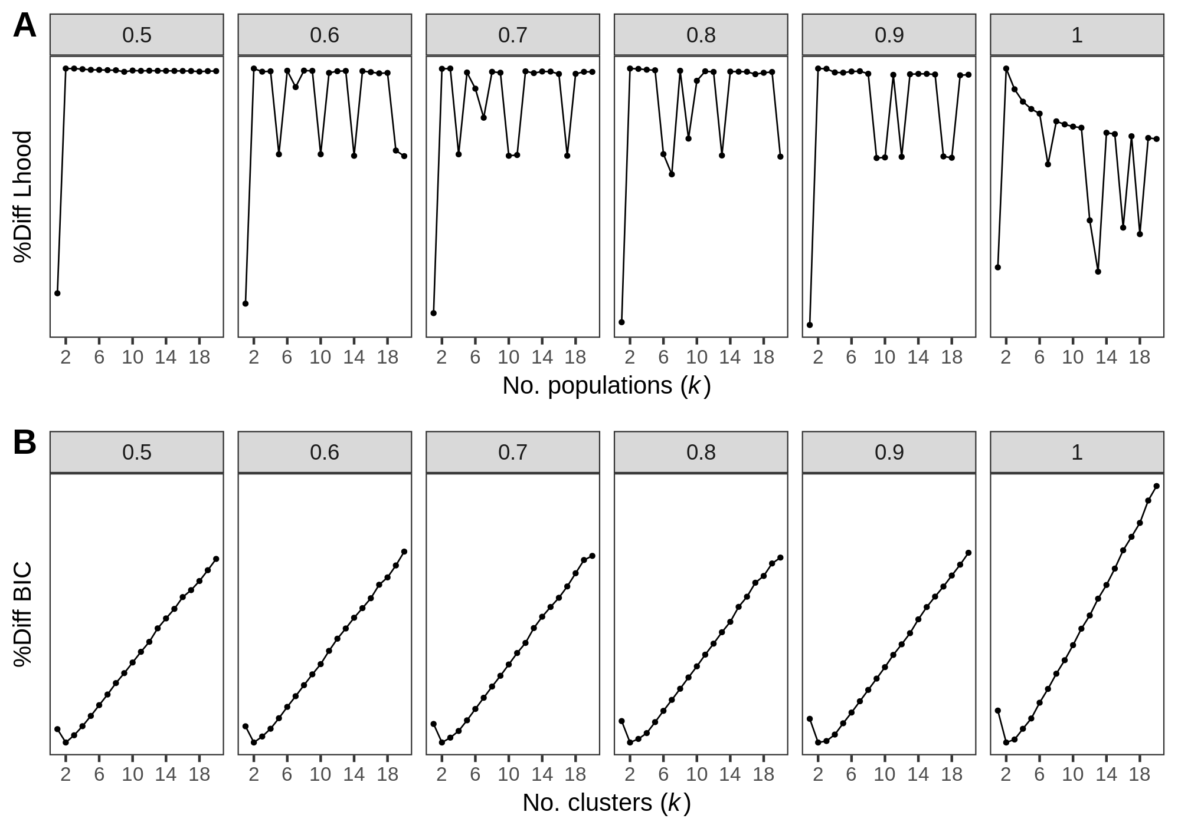
Supplemental Figure S7. Population structure model choice criteria across assembly branches that differed in terms of the threshold of individuals required to maintain a locus in the dataset, and therefore differed in terms of the proportion of missing data. Facets are labeled with the proportion of individuals-per-locus out of 76 individuals (e.g., 0.5 = 50% individuals-per-locus = 38 individuals with locus data required to maintain the locus). A: Marginal likelihoods from fastStructure are maximized at k = 2 for all except one branch (0.7, which narrowly selected k = 3 in this criterion), and resolution decreases as missing data increases. The ChooseK script provided with fastStructure also indicated that k = 2 was the number of model components used to best explain structure in the genetic data for all branches. B: Bayesian Information Criterion (BIC) was minimized at k = 2 genetic clusters in DAPC for all branches. Axes are normalized by percent difference from maximum (fastStructure likelihood) or minimum (DAPC BIC) values. After filtering, the subbranches had the following SNP data statistics:
0.5 = 15,201 SNPs = 34% missing;
0.6 = 13,051 SNPs = 28% missing;
0.7 = 11,440 SNPs = 25 % missing;
0.8 = 9,496 SNPs = 21% missing;
0.9 = 7,214 SNPs = 17% missing;
1.0 = 497 SNPs = 15% missing
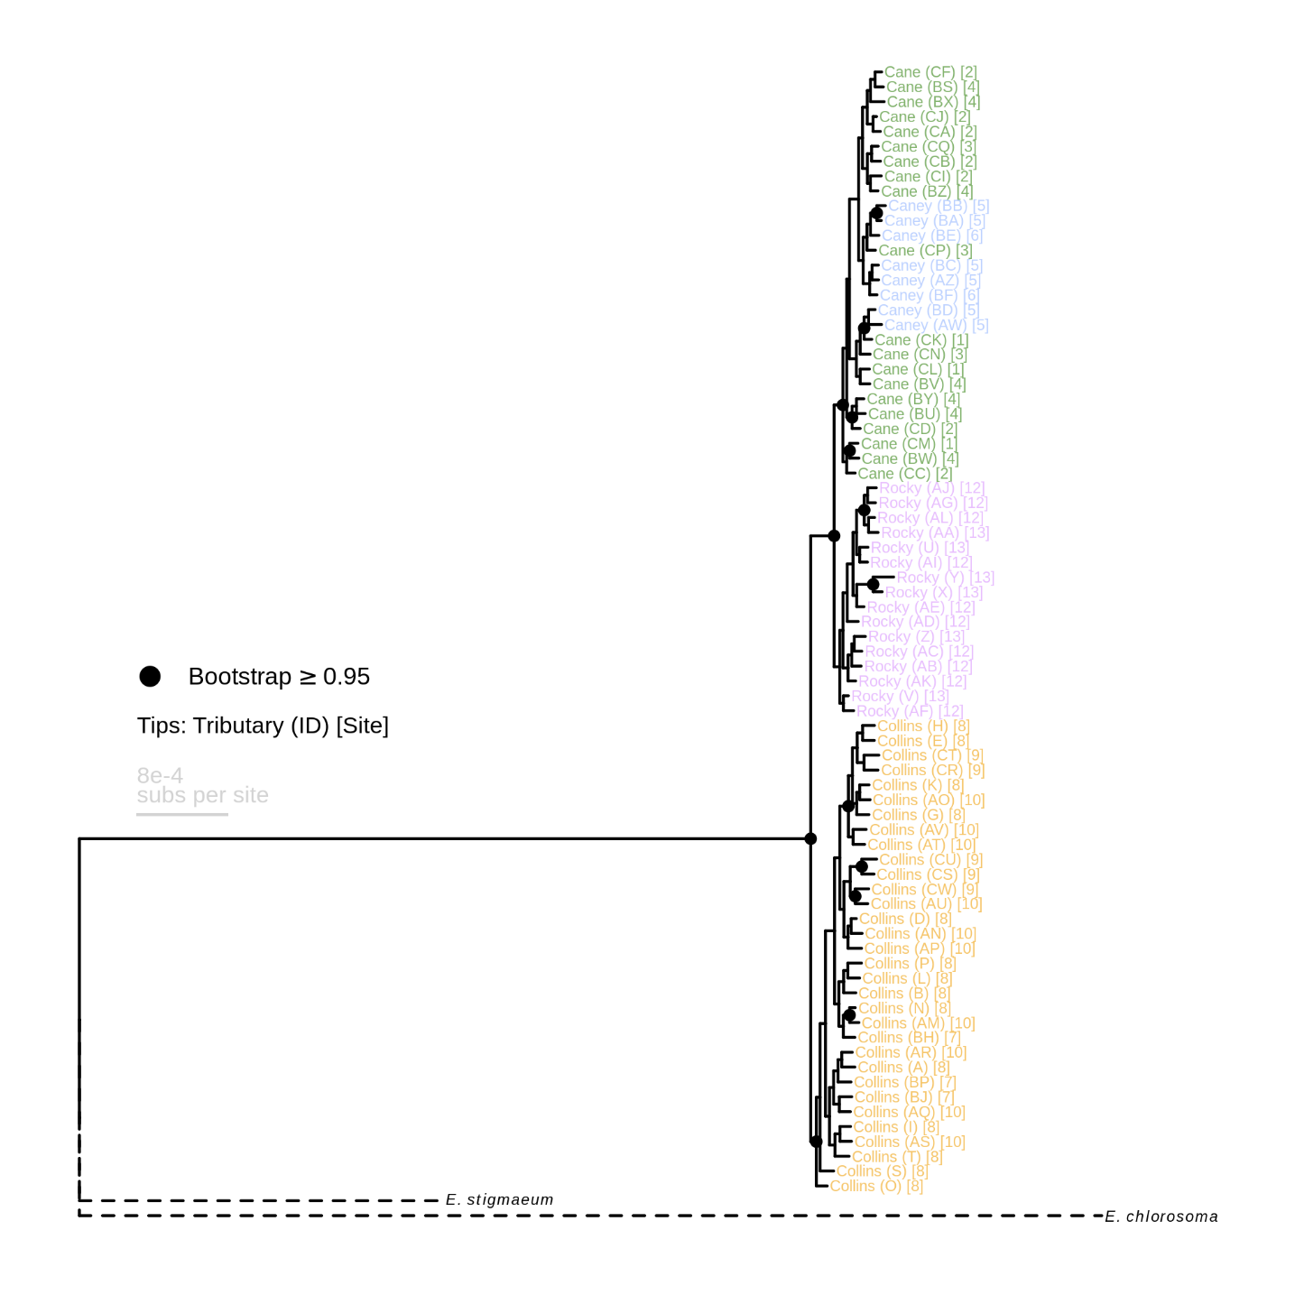
Supplemental Figure S8. Maximum-likelihood phylogeny of Etheostoma akatulo and outgroups Etheostoma stigmaeum and Etheostoma chlorosoma. Dashed outgroup branches are shortened to one half their original length.

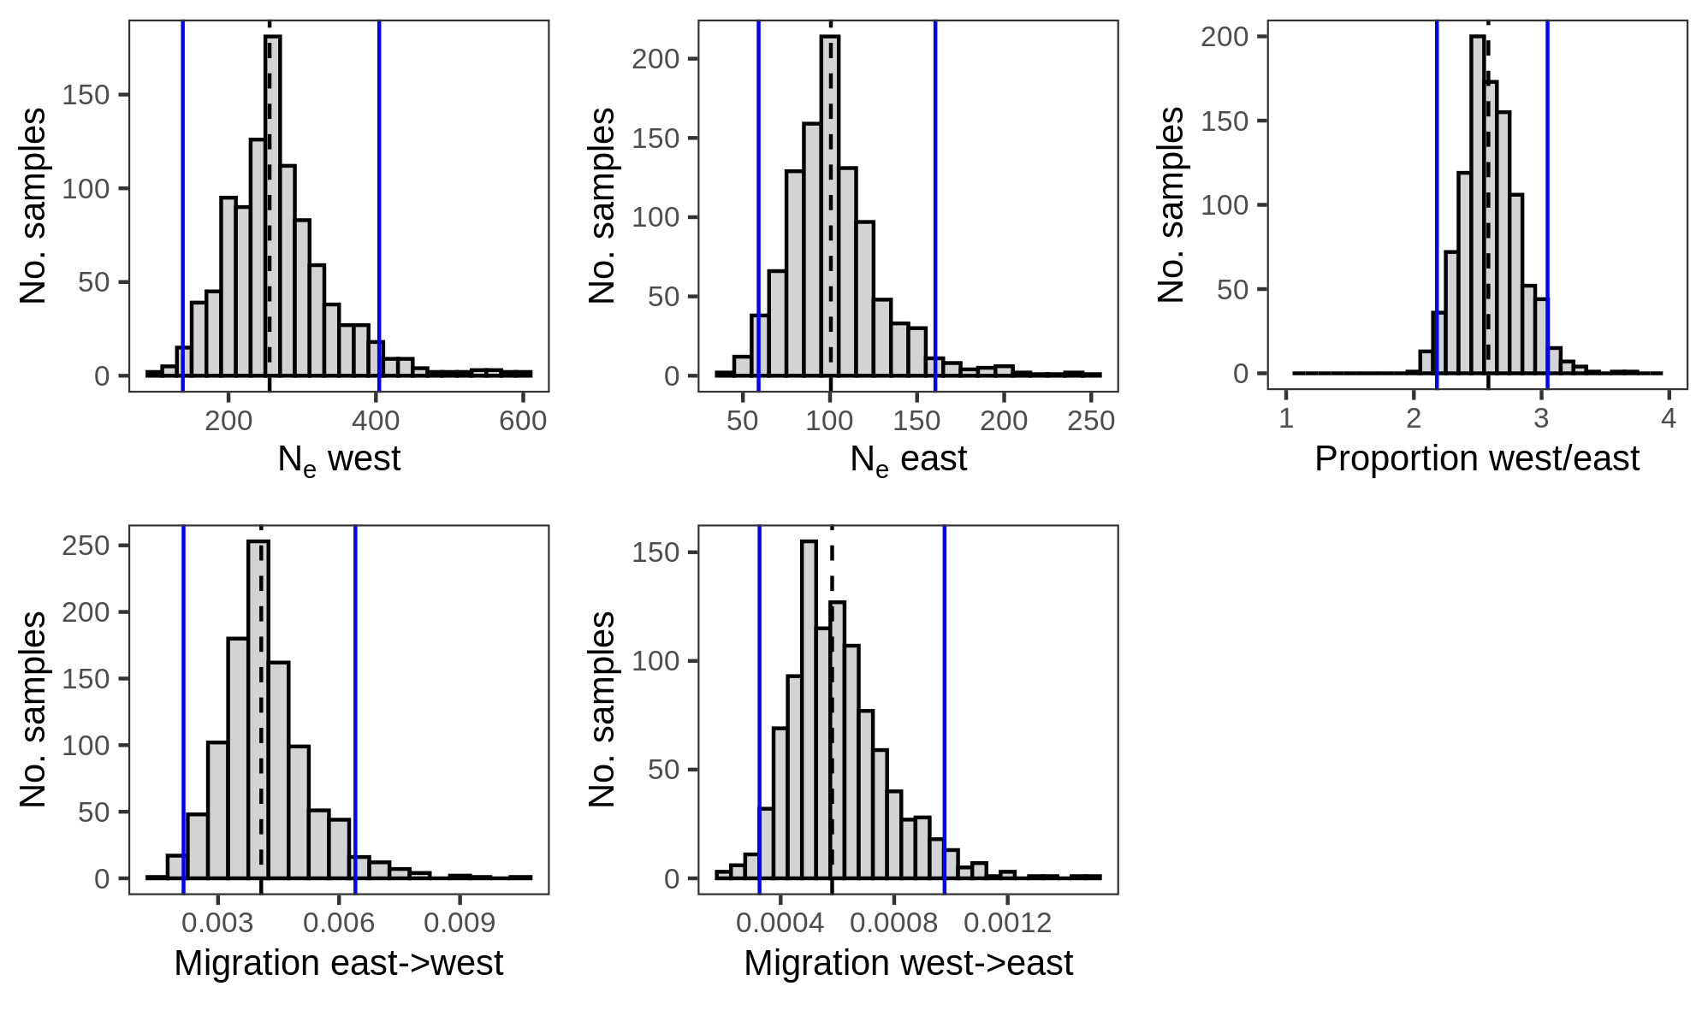
Supplemental Figure S9. Parameter distributions from demographic estimates of western and eastern Etheostoma akatulo populations under the minimum-AIC model, which allowed for migration in both directions. Distributions show values from 1,000 model replicates, each generated from a bootstrapped SFS randomly sampled by site. Model runs were initiated with the maximum likelihood parameters estimated from the full SFS. Dashed lines show median values. Blue lines show 95% HDI. Note different axes and bin widths. 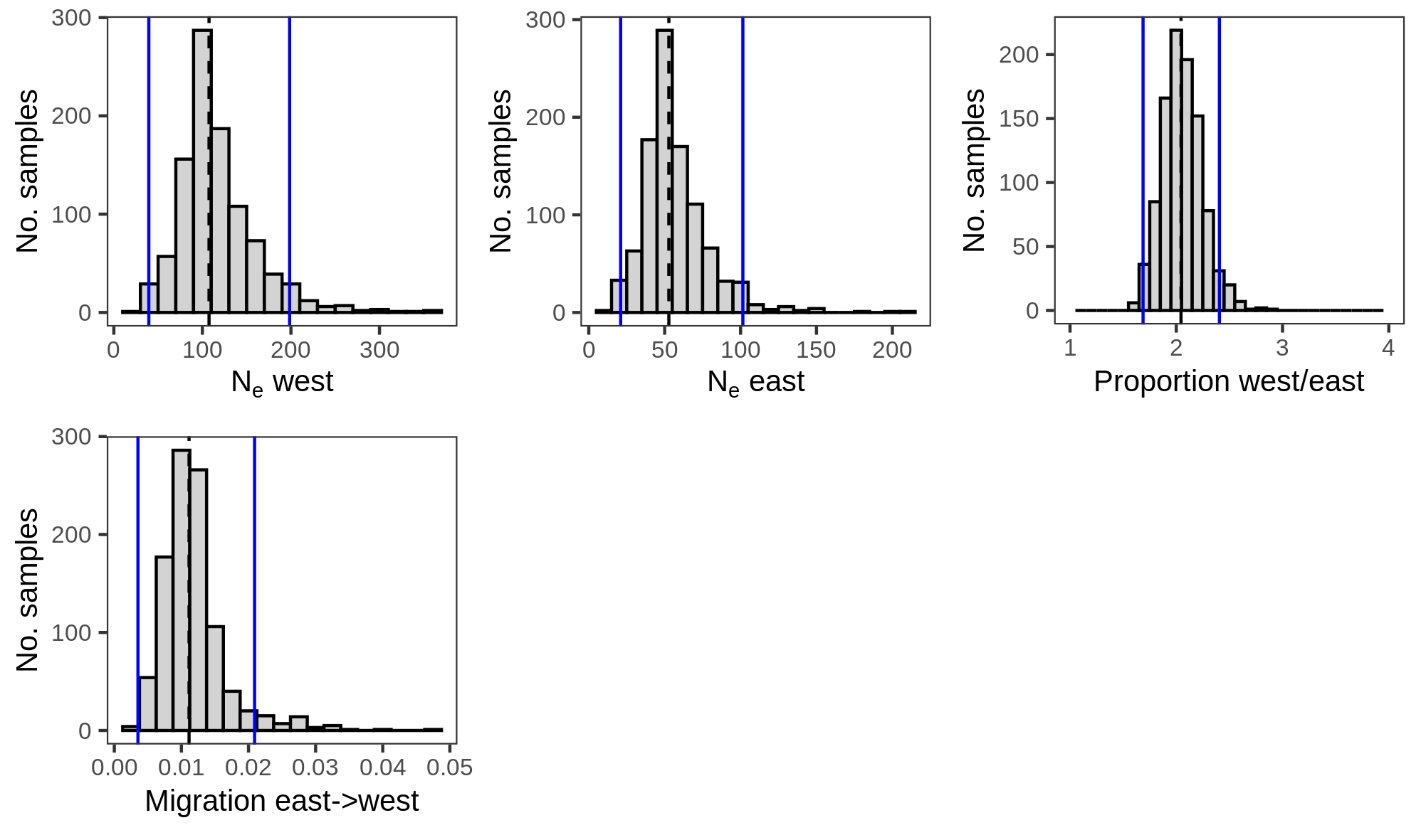
Supplemental Figure S10. Parameter distributions from demographic estimates of western and eastern Etheostoma akatulo populations under the second best model (by AIC), which allowed for migration from east to west only. Distributions show values from 1,000 model replicates, each generated from a bootstrapped SFS randomly sampled by site. Model runs were initiated with the maximum likelihood parameters estimated from the full SFS. Dashed lines show median values. Blue lines show 95% HDI. Note different axes and bin widths.

Supplemental Table S1. Pairwise F_{ST} estimates for populations of Etheostoma akatulo given different population structure assembly subbranches, which differed in terms of the number of individuals required to retain a locus and therefore differed in the amount of missing data. Each tributary comparison contains six values indicating pairwise F_{ST} estimates at 50%, 60%, 70%, 80%, 90%, and 100% individuals-per-locus thresholds, from left to right respectively. The 100% individuals-per-locus branch, which minimized missing SNP data, was used for the main population structure analysis and is shown in bold.
 | Rocky River | Cane Creek | Caney Fork
Collins River | 0.20, 0.21, 0.21, 0.21, 0.21, 0.20 | 0.27, 0.27, 0.28, 0.28, 0.28, 0.29 | 0.24, 0.25, 0.26, 0.26, 0.26, 0.27
Rocky River |  | 0.10, 0.10, 0.10, 0.11, 0.11, 0.11 | 0.10, 0.10, 0.10, 0.11, 0.11, 0.09
Cane Creek |  |  | 0.02, 0.02, 0.02, 0.03, 0.03, 0.05

Supplemental Table S2. Frequency data for Etheostoma akatulo meristic and squamation traits used in morphological divergence analyses. The dataset was drawn from museum records measured by Dr. Steven Layman and reported by Layman and Mayden (2009).
1. Number of lateral line scales (LL)
 | 39 | 40 | 41 | 42 | 43 | 44 | 45 | 46 | 47 | 48 | 49 | 50 | 51
Collins River | 0 | 0 | 0 | 6 | 16 | 14 | 25 | 18 | 12 | 13 | 3 | 2 | 0
Rocky River | 1 | 1 | 1 | 4 | 7 | 9 | 10 | 10 | 3 | 1 | 1 | 0 | 1
Cane Creek-Caney Fork | 0 | 0 | 0 | 1 | 2 | 5 | 13 | 4 | 7 | 2 | 1 | 1 | 0
Calfkiller River | 0 | 0 | 0 | 1 | 1 | 0 | 0 | 1 | 4 | 0 | 4 | 2 | 0

2. Number of transverse scale rows (Trans)
 | 10 | 11 | 12 | 13 | 14
Collins River | 9 | 26 | 67 | 6 | 1
Rocky River | 0 | 3 | 16 | 21 | 9
Cane Creek-Caney Fork | 1 | 0 | 19 | 11 | 5
Calfkiller River | 0 | 0 | 7 | 4 | 2

3. Number of scale rows around the caudal peduncle (CD)
 | 12 | 13 | 14 | 15 | 16 | 17 | 18
Collins River | 1 | 10 | 31 | 62 | 5 | 0 | 0
Rocky River | 0 | 0 | 0 | 10 | 24 | 14 | 1
Cane Creek-Caney Fork | 0 | 0 | 0 | 13 | 20 | 2 | 1
Calfkiller River | 0 | 0 | 0 | 4 | 6 | 3 | 0

4. Number of first dorsal fin spines (D1)
 | 10 | 11 | 12 | 13
Collins River | 8 | 63 | 36 | 2
Rocky River | 0 | 9 | 36 | 4
Cane Creek/Caney Fork | 2 | 17 | 15 | 2
Calfkiller River | 0 | 5 | 7 | 1

5. Number of second dorsal fin rays (D2)
 | 10 | 11 | 12
Collins River | 5 | 80 | 24
Rocky River | 13 | 33 | 3
Cane Creek/Caney Fork | 4 | 24 | 8
Calfkiller River | 5 | 7 | 1

6. Number of anal fin rays (A2)
 | 7 | 8 | 9
Collins River | 6 | 92 | 11
Rocky River | 7 | 38 | 4
Cane Creek/Caney Fork | 4 | 26 | 6
Calfkiller River | 3 | 7 | 3

7. Number of left pectoral fin rays (P1)
 | 13 | 14 | 15 | 16
Collins River | 0 | 39 | 70 | 0
Rocky River | 1 | 20 | 26 | 2
Cane Creek/Caney Fork | 0 | 15 | 21 | 0
Calfkiller River | 3 | 9 | 1 | 0

8. Percentage of the nape scaled (Nape)
 | 40% | 50% | 60% | 70% | 80% | 90% | 95% | 100%
Collins River | 0 | 0 | 0 | 3 | 5 | 15 | 0 | 86
Rocky River | 0 | 0 | 7 | 19 | 12 | 9 | 1 | 1
Cane Creek/Caney Fork | 1 | 3 | 4 | 15 | 7 | 4 | 0 | 2
Calfkiller River | 2 | 0 | 2 | 6 | 2 | 1 | 0 | 0

9. Percentage of the cheek scaled (Cheek)
 | 40% | 50% | 60% | 70% | 80% | 82% | 90% | 100%
Collins River | 0 | 0 | 0 | 0 | 2 | 1 | 29 | 77
Rocky River | 2 | 3 | 1 | 3 | 13 | 0 | 13 | 14
Cane Creek/Caney Fork | 0 | 2 | 1 | 2 | 12 | 0 | 13 | 6
Calfkiller River | 0 | 0 | 1 | 1 | 1 | 0 | 9 | 1

10. Percentage of the opercle scaled (Opercle)
 | 60% | 70% | 80% | 90% | 100%
Collins River | 0 | 0 | 2 | 23 | 84
Rocky River | 1 | 0 | 2 | 9 | 37
Cane Creek/Caney Fork | 0 | 1 | 1 | 6 | 28
Calfkiller River | 1 | 1 | 2 | 9 | 0

